**Modern Artificial Intelligence**

**Individual Assignment**

**Name: Jeslyn Ho Ka Yan**

**ID: 8535383**

**Table of Content**

1 Introduction 3

2 Electric Vehicles Tec 4

# Question 1

**Loss(*x, y, z, w*) = 4(*x*2*y*2 + 3min*{w, z} + 2w*)*.***

x = 4, y = -2, z = 5 and w = -1.

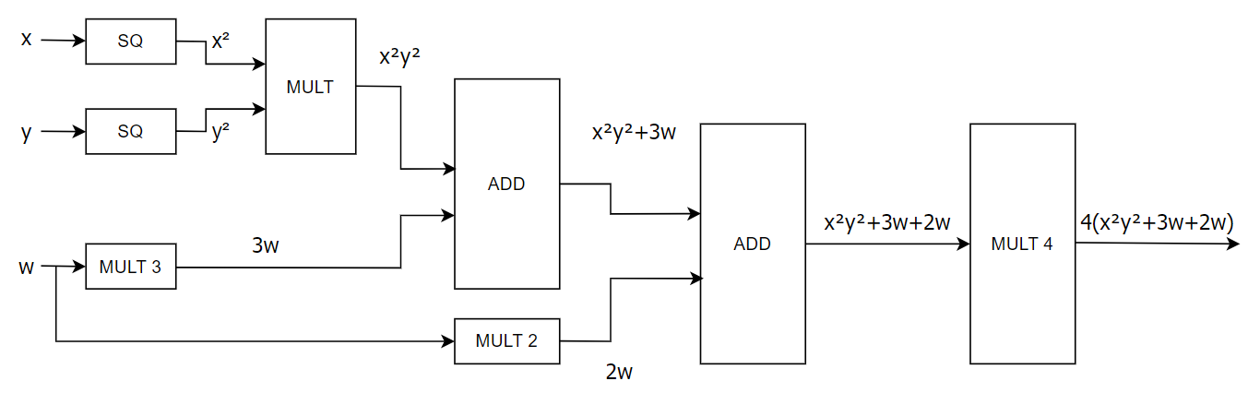

# Electric Vehicles Tec